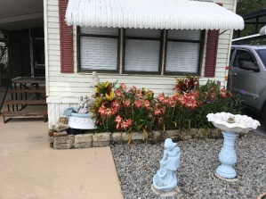 **2020 what a ghastly year!**   
Who’d of thunk a looming pandemic was near?  
The news from us; for you, about square dancing is blue  
  
January: At our Florida Strawberry Squares getaway.   
We were all so very gay  
Dances with return invites for twenty-one.  
As well as others not previously done.

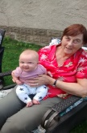February: Back in MA.   
A hectic calling schedule to keep for sure.  
No room in the calendar for any more.  
Cold nights and warm days with the bright sun  
Sticky Maple Sap starts to run.   
Boiling; It takes long hours on our feet  
For a successful season of the natural treat.   
A 90th birthday party for a special one.   
Never before had she had so much fun.

March: Started 4 nights of calling; then quarantine came.  
The busy schedule is now a has been.  
  
April: Began improvements & additions to the yard.   
Pounding /sawing / building was hard.   
A pergola with patio, using hundreds of bricks.   
The herring bone pattern was quite a trick.  
  
May: A new granddaughter born in May  
We have to wave through a window, and try to say Hey!  
  
June: Don’s birthday 65; Let’s all give him a high five.  
How to celebrate? In the pandemic state?   
A surprise card shower  
This idea did bloom and flower  
200 + greetings from all was felt  
A BIG THANK YOU to all who helped.   
A huge outpouring of love was dealt.   
He heard from many friends, some far away.   
Let’s hear it for Square Dancers hip hip hooray!   
  
Alas, June was not done with us yet.   
The family box business of 90 years met.   
Another victim of the pandemic

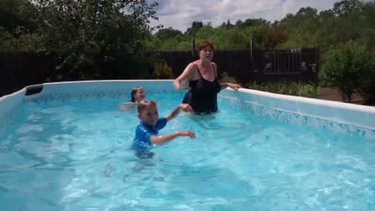July: A scorcher so fortunate to have a pool.   
Many swims daily, we ain’t no fools.

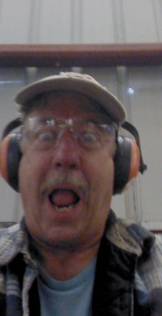  
August: Brings a surprise guest, from across the sea.   
Arrives with fresh Lobsters from Newberry   
The patio finished just days before  
More good times to come for sure.  
 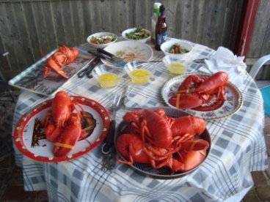 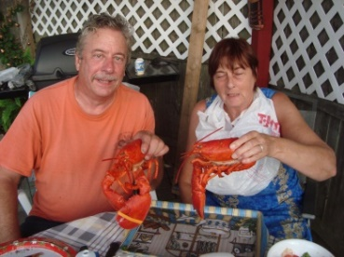 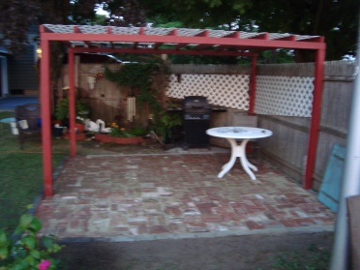  
September:   
Our Maples are shedding those leaves of gold.   
Raking and cleaning does take its toll   
A knee replacement for Don is looming. >>>>>>>>>>  
This situation has left him fuming.   
The surgery needs to be done for sure.   
He wants to get back out, on the dance floor!  
Other medical surgeries for both took place.   
New eyes, less teeth all in this state.  
Shall we fear?  
The start of these GOLDEN YEARS?  
Roku, puzzles cards, dice and scrabble word games.  
Keep our anxieties / impatience tamed  
We have continued in our isolation.  
And try not to feel desolation.  
 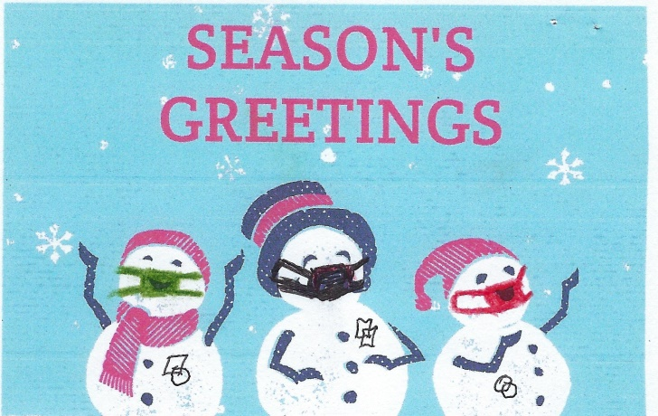  
 Wishing you a Happy Holiday Season   
 and looking forward to a Brighter 2021.

**\*\*\*PS. It is with much dismay that we must say.\*\*\***  
This may be our last correspondence this way.  
With the Pandemic taking our jobs, and pastime away  
We regret and are sorry for this sad day.  
Decisions about this web site and square dance costs.  
A request to the web master seems to have fallen as a loss.  
To our financial impact we must concede.  
We have to slow down the bleed.  
To make a hard choice after 8 year.  
And pull the plug on our contents here.  
  
E-mails and Facebook may be our ways of the future near.  
  
We wish you all the best and hope you understand our position.   
Hopefully one day we can return with a mission.  
  
Thank you ALL for allowing us into your busy lives.   
We hope to see you someday on the dance floor again.  
Our Square Dance Friends we sure do miss.  
We send you all virtual YELLOWROCKS and Kiss!

Sincerely   
Sally-Ann & Don